CS4K8 Etoys
Unit 4 Champaign Schools

Project Title | CS4K8 Word Ladder Five
Author | Elizabeth Slifer
Project Image | 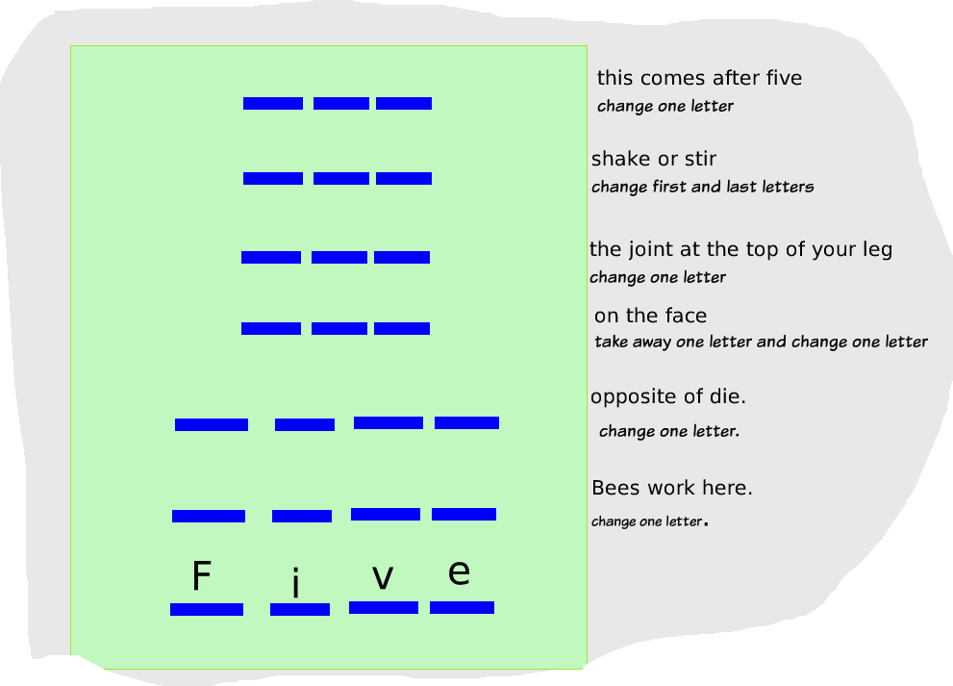
Grade Level | Second grade
Curriculum Topic | Number words, problem solving
Vocabulary | Five, hive, live, hip, lip, mix, six
Project Description | Students will start at the bottom and using clues and letters already on the ladder find answers to the rest of the puzzle.
Scripts Images | Maker buttons was used to create new playfield. But learner must draw letters or use the TEXT button for individual letters.
Extend
Extend
Advice
Hints
Links
Common Core

